Guiding Dialogue for Course-Level & Program-Level Assessment (Excerpts for Assessment Friday, April 25, 2014)

Compiled by:
Robyn Wornall, Ph.D., Director of Institutional Research and

Stephanie Burns, Ph.D., Faculty SLO Coordinator 2011-2012

Outcomes Assessment Process:

The following diagram depicts the outcomes assessment process.
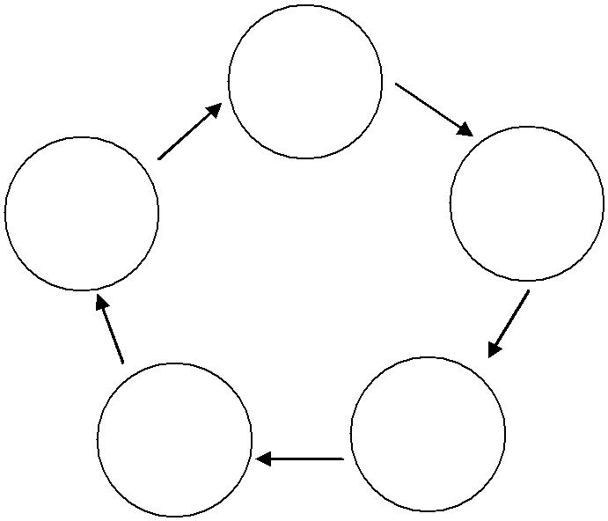

1. Identify
Outcome(s)

5. Improve |  | 2. Establish
5. Improve |  | Method &
Course or |  | Method &
Course or | STUDENT | Criteria for
Program | STUDENT | Success
 | LEARNING | Success

4. Summarize | 3. Assess
& Analyze | Outcome(s)
Data

Some notable features of the process include the following:

- The focus is on STUDENT LEARNING and IMPROVEMENT of student learning. The focus is not on assessment practices (including templates and forms) themselves. Therefore, dialogue should focus on the data and what it means about student learning and how to improve it.

- The process involves more than the collection of evidence. That is, the process does not stop at steps 3 or 4. What you do with the evidence collected is what matters.

- If you stop once you’ve collected the data (i.e., by “checking the box” that you’ve completed steps 3 or 4), you never get the improvement/benefit for your course, program, or students.

- In sum, you need to close the loop and implement new strategies in order to improve student learning.

The “Suggested Questions to Consider” in the following section are intended to guide dialogue and keep the focus on student learning and improvement.

Suggested Questions to Consider When Analyzing/Discussing Assessment Data:

So, you’ve collected data. Now what? The following questions are intended to help guide analysis and discussion of assessment results – specifically to identify areas for improvement.

Guiding Assessment Dialogue

Page 1 of 3
- Preliminary Questions:

  - Compare the results with the criteria for success that were established in step 2 of the outcomes assessment process.
  - Were the criteria for success met?

  - Gap analysis: comparison of actual outcomes with intended/targeted outcomes – what worked and what needs to be changed?

  - How well are students doing compared to a standard? (rubric or established criteria for success)

  - In what outcome/skill areas are a large number of students still weak?

  - How much did students gain? (requires a pre- and post-test/evaluation)

  - What was surprising about the findings/results?

  - Are you collecting and recording assessment data with enough detail to answer the questions above (examples: specific areas of weakness, what specifically needs to be changed to improve student learning?) For example, instead of recording only the average score, add detail that will help you identify areas for improvement: The average score on the 20 assessment questions for this SLO was 65%. Many students in both of sections had difficulty with quantitative problem solving and concept questions, particularly those involving more than one variable. The students in the section that were provided more worksheets and practice problems performed better than the section that had fewer of these supports/assignments.

  - Are there other assessment methods that might be used to drill down and gain greater/different insight into student learning?

- If Results Are Surprising, Review and Consider the Following:

  - Is the alignment correct? – Between the course-/program-level outcome(s) and the assessment instrument? – Between the outcome(s) and course activities? – Between the outcome(s) and the evidence (i.e., what was measured/collected)? – Between the outcome(s) and the curriculum? Are the SLOs congruent with the Course outline of record?

  - Were the assessment instructions clear?

  - Would a different assessment/tracking method be more appropriate? Would multiple measures give more information? (Example: If students are being assessed at one juncture, would comparing across multiple assignments (to track improvement) help? Can you then discern improvements across assignments?)

  - Do different groups of students perform differently on the assessments? If so, you might want to examine performance among subgroups of students – examples: completion of English/Math courses prior to enrollment in your course, demographic groups, learning style, college experience, etc.

- Identify Areas for Improvement:
  - How can we improve student learning based on the results?

  - Discuss findings with all discipline faculty in your department, identify commonalities in areas that need improvement.
  - Are improvements needed in the following:
Assessment instruments and processes?
Pedagogy and curriculum?

Student support?
Faculty support (professional development opportunities)?
Resources (equipment/supplies/space/budget)?

Guiding Assessment Dialogue

Page 2 of 3
- Delve Deeper:

  - Consider collecting indirect assessment information to complement direct evidence collected through course-level assessment

  - Triangulate using multiple methods of assessment

  - Are students aware of the course-level outcomes? Can they articulate them? Note: Data have been collected through PEP student surveys since 2006.
  - How well do students do in subsequent courses?
  - Have students’ attitudes changed? How? In what specific ways?

Some of the information included here was compiled from materials included in Resource Binder for WASC Retreat on Assessment in Practice, October 27-29, 2011

Guiding Assessment Dialogue

Page 3 of 3

